LEGALEASE
AI-Powered Legal Document Generator
A Project Report
Submitted in partial fulfillment of the requirements
for the completion of the project
Submitted By
TAMINA FATHIMA .M - 2526J0111
DHARSHINI .A - 2526J0083
DIVYADHARSHINI .S - 2526J0084
GOMATHI .M - 2526J0085
HARINI .S - 2526J0087
DEPARTMENT OF INFORMATION TECHNOLOGY
NAVARASAM ARTS AND SCIENCE COLLEGE FOR WOMEN, ERODE
B.Sc. INFORMATION TECHNOLOGY
BHARATHIAR UNIVERSITY
2026

ABSTRACT
LegalEase is an AI-powered legal document generator developed to assist users in preparing structured agreement-style document drafts through a simple web application. The system accepts information such as document type, parties, terms and effective date and uses a generative AI service to produce a draft.
The application is developed using Python technologies. Streamlit is used for the interactive frontend, while FastAPI provides backend REST API services. The AI generation layer integrates the Google Gemini API through the Google GenAI Python SDK. The project also contains document-formatting functionality for TXT, DOCX and PDF output.
LegalEase follows a modular architecture in which separate components handle user interaction, API routing, request schemas, AI generation and document formatting. A local fallback mechanism is included to demonstrate document generation when the external AI service is temporarily unavailable.
1. INTRODUCTION
1.1 Background
Legal documents and agreements are often prepared by editing templates and manually entering party details, terms and dates. This can involve repetitive work, especially when a user needs a structured draft quickly.
Generative Artificial Intelligence provides an opportunity to create applications that can transform structured user input into natural-language drafts. LegalEase is developed as an academic demonstration of this approach.

1.2 LEGALEASE
LegalEase is a web-based AI-assisted application that generates agreement-style legal document drafts from information supplied by the user. The application provides a single interface for selecting a document category and entering the information required for generation.
The major functions of LegalEase are:
• Student Project Agreement generation
• Rental Agreement draft generation
• Employment Agreement draft generation
• Non-Disclosure Agreement draft generation
• Service, Partnership and Sale Agreement draft generation
• TXT, DOCX and PDF document export
1.3 NEED FOR THE SYSTEM
Users may need a structured starting draft without repeatedly searching for templates and formatting documents manually. LegalEase combines document selection, input collection, AI-assisted drafting and file export into one application.
1.4 SCOPE
The scope includes academic and demonstration-oriented agreement-style document drafting, AI-assisted text generation, local document formatting and downloadable output. The system is not a substitute for professional legal advice or legal review.

2. OBJECTIVES
1. To develop an AI-powered legal document drafting application.
2. To provide a simple interface for selecting a document type.
3. To accept party details, terms and effective date as structured input.
4. To integrate Google Gemini for generative document drafting.
5. To connect a Streamlit frontend with a FastAPI backend.
6. To provide downloadable TXT, DOCX and PDF outputs.
7. To organize the application into reusable modules.
8. To handle temporary AI-service failures using a fallback mechanism.
9. To demonstrate a complete AI-enabled software project for academic purposes.
10. To provide a convenient starting draft that can be reviewed and edited by the user.

3. EXISTING SYSTEM
In a conventional document preparation process, users may search for templates, copy content into a word processor, replace names and terms manually, format the document and then save it in the required format.
3.1 LIMITATIONS OF EXISTING SYSTEM
1. Users need to search manually for suitable document templates.
2. Party details and terms must often be edited manually.
3. Formatting work may need to be repeated for different documents.
4. Different output formats may require separate conversion steps.
5. Maintaining consistent structure can require additional effort.
6. Users may spend time preparing a draft before reviewing its content.
7. The process does not provide an integrated AI-assisted drafting workflow.

4. PROPOSED SYSTEM
The proposed system, LegalEase AI, is an AI-assisted legal document generator designed to create structured agreement-style drafts from user-provided information. The system integrates a simple web interface with a FastAPI backend and a Gemini-based generation layer.
The user selects the document type, enters parties and terms, chooses the effective date and submits the request. The backend processes the information and returns the generated draft to the frontend.
4.1 FEATURES OF PROPOSED SYSTEM
1. AI-assisted agreement-style document generation.
2. Multiple document categories.
3. Simple form-based user interface.
4. FastAPI REST API integration.
5. Gemini API integration.
6. Local fallback generation when configured AI service is unavailable.
7. TXT, DOCX and PDF export.
8. Modular project structure.
4.2 ADVANTAGES OF PROPOSED SYSTEM
1. Reduces repetitive drafting and formatting work.
2. Provides a single workflow for document generation.
3. Supports multiple output formats.
4. Demonstrates practical generative AI integration.
5. Separates frontend, backend, AI and formatting responsibilities.
6. Can be extended with additional document types and features.

5. SYSTEM REQUIREMENTS
System requirements specify the hardware and software components required to develop and run the LegalEase application successfully.
5.1 HARDWARE REQUIREMENTS
Component | Requirement
Processor | Intel Core i3 or above
RAM | Minimum 4 GB
Storage | Minimum 10 GB free space recommended
Display | 1366 × 768 or above
Keyboard | Standard keyboard
Mouse | Standard mouse
Internet | Required for Gemini API service
5.2 SOFTWARE REQUIREMENTS
Component | Requirement
Operating System | Windows / Linux / macOS
Programming Language | Python 3.x
Backend Framework | FastAPI
Frontend Framework | Streamlit
AI Service | Google Gemini API
Development Environment | Visual Studio Code
Browser | Google Chrome / Microsoft Edge
Environment | Python virtual environment

5.3 TECHNOLOGIES USED
Python
Python is the main programming language used for backend development, AI integration and document-processing logic.
Streamlit
Streamlit is used to build the interactive frontend through which users select document types, enter information and view generated content.
FastAPI
FastAPI is used to create the backend REST API and manage requests such as health checks, document generation and file export.
Google Gemini API
The Gemini API provides the generative AI capability used to create agreement-style document drafts from structured prompts.
python-docx
python-docx is used to create downloadable DOCX documents.
ReportLab
ReportLab is used to create PDF output from generated document content.
Requests
Requests is used by the frontend to communicate with the backend API.
Visual Studio Code
Visual Studio Code is used as the development environment for writing, organizing, running and testing the project.

5.4 FUNCTIONAL REQUIREMENTS
1. The system should allow the user to select a document type.
2. The system should accept party information.
3. The system should accept document terms.
4. The system should accept an effective date.
5. The system should send the request to the backend.
6. The system should generate and display document content.
7. The system should provide TXT download.
8. The system should provide DOCX download.
9. The system should provide PDF download.
10. The backend should provide a health-check endpoint.
5.5 NON-FUNCTIONAL REQUIREMENTS
1. Usability – The interface should be simple and understandable.
2. Performance – Normal local requests should be processed within a reasonable time.
3. Reliability – The application should handle errors without crashing.
4. Security – API credentials should be stored in environment variables.
5. Maintainability – Code should be divided into logical modules.
6. Portability – The application should run in a standard Python environment.
7. Extensibility – New document types and export formats should be addable.

6. SYSTEM ARCHITECTURE
The system architecture describes the overall structure and working flow of LegalEase. It shows how user input travels from the Streamlit interface to the FastAPI backend, then to the AI generation component and finally back to the user.
6.1 ARCHITECTURE FLOW
USER
↓
STREAMLIT WEB INTERFACE
↓
FASTAPI REST API
↓
DOCUMENT REQUEST SCHEMA
↓
GEMINI DOCUMENT GENERATOR
↓
GENERATED AGREEMENT-STYLE DRAFT
↓
DOCUMENT FORMATTER
↓
TXT / DOCX / PDF
↓
USER
6.2 WORKING PROCESS
1. User opens the LegalEase web application.
2. User selects a document type.
3. User enters parties, terms and effective date.
4. Frontend sends a POST request to the /generate endpoint.
5. FastAPI validates and processes the request.
6. The generator prepares the AI prompt.
7. Gemini generates the draft when available.
8. The configured fallback can respond when the external AI service is temporarily unavailable.
9. The result is returned to the frontend.
10. The generated document is displayed and can be downloaded.

6.3 MAIN COMPONENTS
1. User Interface – Provides document selection, input fields and output display.
2. FastAPI Backend – Handles API requests and application logic.
3. Request/Response Schemas – Define structured data exchanged between frontend and backend.
4. Gemini Generator – Prepares prompts and communicates with the Gemini API.
5. Fallback Generator – Provides a local demonstration document when the AI service cannot be used.
6. Document Formatter – Creates TXT, DOCX and PDF representations.
7. Configuration – Loads environment-based settings such as the Gemini API key.
7. MODULES
The LegalEase system is divided into modules. Each module performs a specific function and together they provide an integrated AI-assisted document generation workflow.

7.1 USER INTERFACE MODULE
The User Interface Module is implemented using Streamlit. It provides controls for selecting a document type, entering party information, entering terms and choosing an effective date. It also displays the generated document and download options.
7.2 API ROUTING MODULE
The API Routing Module is implemented in routes.py. It provides endpoints for health checking, document generation and export operations. It receives structured requests from the frontend and returns suitable responses.
7.3 REQUEST SCHEMA MODULE
The schema module defines the request and response structures used by the backend. It helps maintain consistent communication between the frontend and API.
7.4 GEMINI DOCUMENT GENERATOR
The Gemini Document Generator manages the AI request. It receives the document details, prepares a structured prompt and calls the Gemini API. The API key is loaded from the environment rather than hard-coded.
7.5 FALLBACK GENERATION MODULE
The fallback mechanism provides a predefined academic demonstration document when the external AI service is temporarily unavailable. This helps the project remain demonstrable even during temporary service interruptions.

7.6 DOCUMENT FORMATTER MODULE
The Document Formatter handles the creation of downloadable document formats. The project supports plain TXT output and uses python-docx and ReportLab for DOCX and PDF generation.
7.7 MAIN APPLICATION MODULE
The main application module creates the FastAPI application and connects the router. It provides the entry point used by Uvicorn to start the backend server.
8. IMPLEMENTATION
The implementation phase describes how LegalEase is developed using Python, Streamlit, FastAPI, Google Gemini API, python-docx and ReportLab.
8.1 DEVELOPMENT ENVIRONMENT
The project is developed in Visual Studio Code using a Python virtual environment. Dependencies are maintained in requirements.txt. Environment variables are stored in the .env file.
8.2 BACKEND IMPLEMENTATION
The backend contains main.py, routes.py, schemas.py, config.py, the AI generator and document-formatting services. Uvicorn is used to run the FastAPI application.

8.3 FRONTEND IMPLEMENTATION
The frontend is implemented in frontend/app.py using Streamlit. It contains the application title, sidebar information, document-type selector, parties field, terms field, effective-date input, generate button and generated-document area.
The frontend communicates with the backend using HTTP requests. The generated content is stored in Streamlit session state so it can remain available while the page is used.
8.4 AI INTEGRATION
The AI integration is implemented through the Google GenAI Python SDK. The Gemini API key is loaded from .env. The generator sends a structured prompt containing document type, parties, terms and effective date.
The application also includes error handling and fallback behavior for temporary external-service failures.
8.5 DOCUMENT EXPORT
TXT output is provided as plain text. DOCX output is created using python-docx. PDF output is created using ReportLab with an A4 page layout.

8.6 PROJECT STRUCTURE
The project follows a modular folder structure:
legalease AI
├── .venv
├── .env
├── requirements.txt
├── backend
│ ├── ai_core
│ │ └── gemini_generator.py
│ ├── services
│ │ └── document_formatter.py
│ ├── routes.py
│ ├── main.py
│ ├── schemas.py
│ └── config.py
└── frontend
└── app.py
8.7 IMPLEMENTATION STEPS
1. Install Python and Visual Studio Code.
2. Create the LegalEase project folder.
3. Create and activate the Python virtual environment.
4. Install required packages from requirements.txt.
5. Configure the Gemini API key in .env.
6. Develop the FastAPI backend.
7. Develop the Streamlit frontend.
8. Implement Gemini generation and fallback handling.
9. Implement TXT, DOCX and PDF export.
10. Run and test the backend and frontend locally.

8.8 IMPLEMENTATION
The following screenshots can be inserted in this section from the actual development environment.
Figure 8.1: LegalEase AI Project Structure in Visual Studio Code
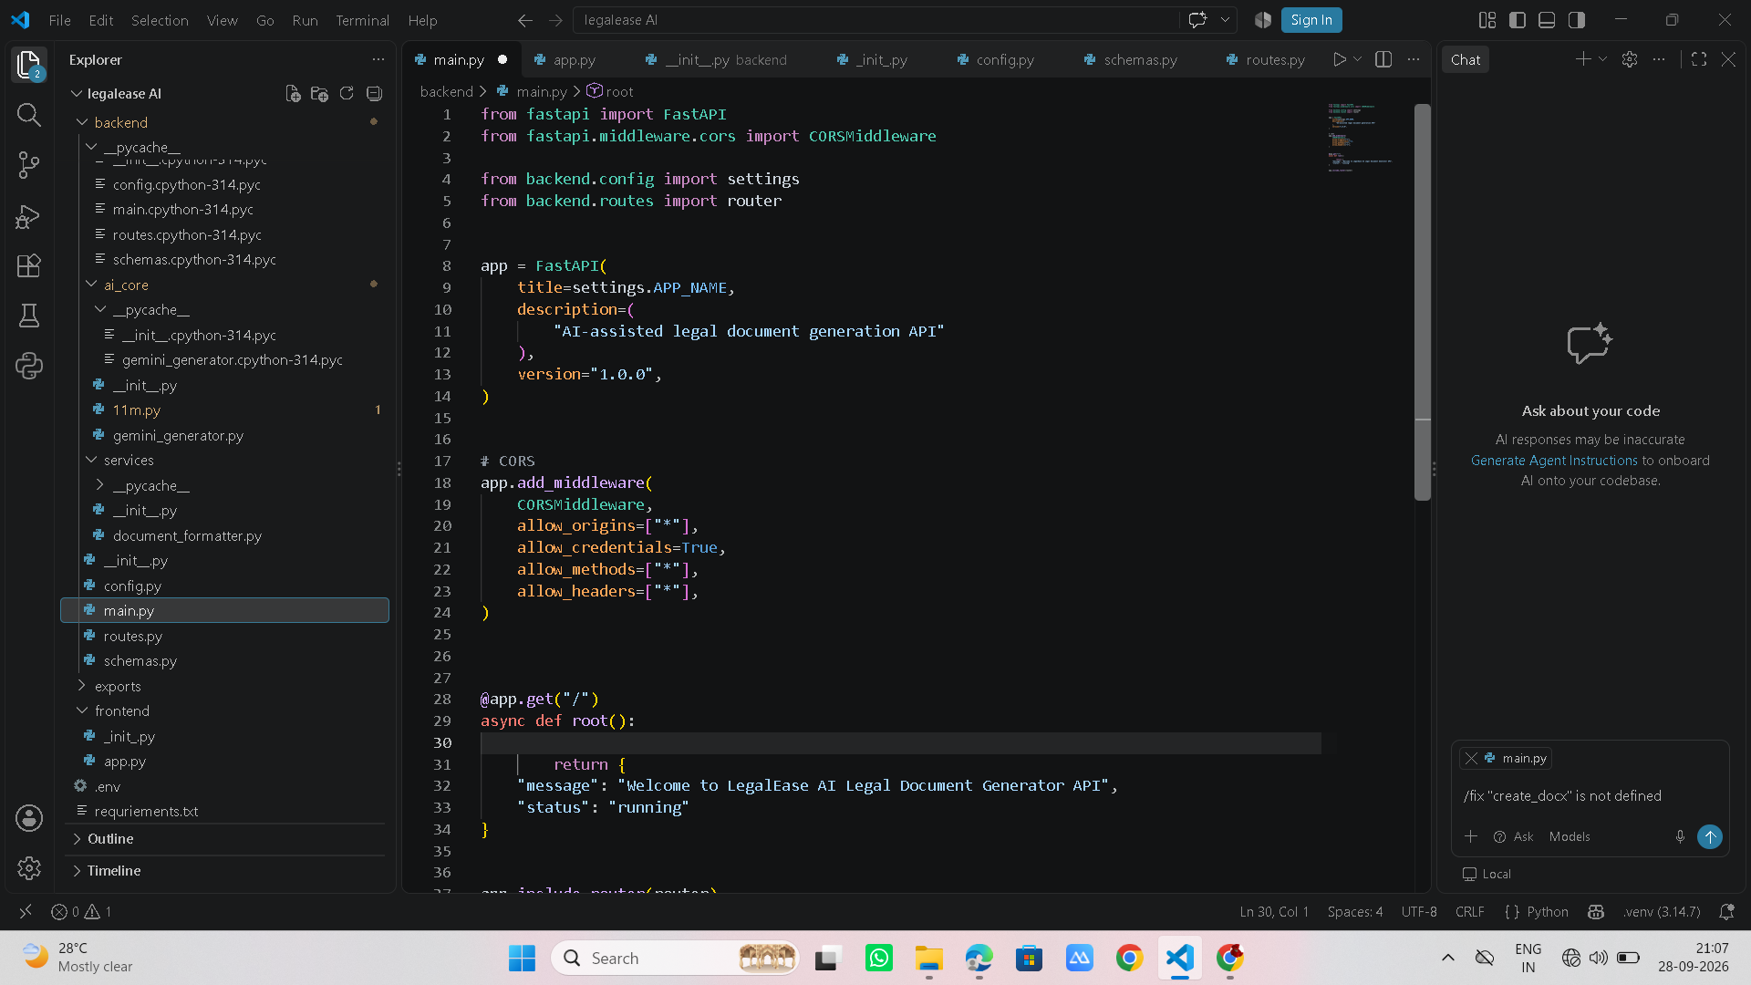
8.8.1 Main Application
Figure 8.2: LegalEase AI Main Application Interface

8.8.2 AI INTEGRATION
Figure 8.3: Gemini AI Integration in LegalEase
The AI generation component prepares a structured prompt from the selected document type, party information, terms and effective date. The result is returned to the FastAPI route and displayed in the Streamlit application.
8.8.3 SERVER EXECUTION
The backend can be started using:
python -m uvicorn backend.main:app --reload
The Streamlit frontend can be started using:
streamlit run frontend/app.py
Figure 8.4: FastAPI Server Execution

9. TESTING
Testing is an important phase in the development of LegalEase. It is performed to identify errors, verify the functionality of individual components, confirm communication between frontend and backend, and ensure that document output is produced correctly.
9.1 TESTING OBJECTIVES
1. To verify the functionality of the application.
2. To identify and correct errors.
3. To verify communication between Streamlit and FastAPI.
4. To verify document-generation requests.
5. To verify the AI integration and fallback behavior.
6. To verify TXT, DOCX and PDF output.
7. To ensure the application provides the expected result.
9.2 TYPES OF TESTING
9.2.1 Unit Testing
Individual functions such as generation and document formatting are checked separately.
9.2.2 Integration Testing
Communication between the frontend, FastAPI backend, AI layer and export functions is verified.
9.2.3 Functional Testing
Each user-facing feature is checked against its expected behavior.
9.2.4 User Interface Testing
The interface controls, generated-output display and download buttons are checked.

9.3 TEST CASES
Test Case | Input / Action | Expected Result | Status
TC01 | Open application | Streamlit home page loads | Pass
TC02 | Select document type | Selected type is accepted | Pass
TC03 | Enter parties and terms | Input is accepted | Pass
TC04 | Generate document | Generated content is displayed | Pass
TC05 | Check /health | Healthy response is returned | Pass
TC06 | Download TXT | TXT file downloads | Pass
TC07 | Download DOCX | DOCX file downloads | Pass
TC08 | Download PDF | PDF file downloads | Pass
TC09 | Temporary AI failure | Fallback/demonstration output is available | Pass
TC10 | Submit invalid/empty input | Application handles the request appropriately | Pass
9.4 TESTING RESULT
The testing process verifies that the major components of LegalEase work together as intended. The application can accept structured input, communicate with the backend, generate or fall back to a document draft, display the result and provide downloadable formats.

10. OUTPUT
The output of LegalEase demonstrates the working of the developed web application and the generated agreement-style document. Screenshots provide visual evidence of the application interface and generated result.
10.1 HOME PAGE
The Home Page is the main interface of the LegalEase application. It allows the user to select a document type and enter the required information.
Figure 10.1: LegalEase AI Home Page
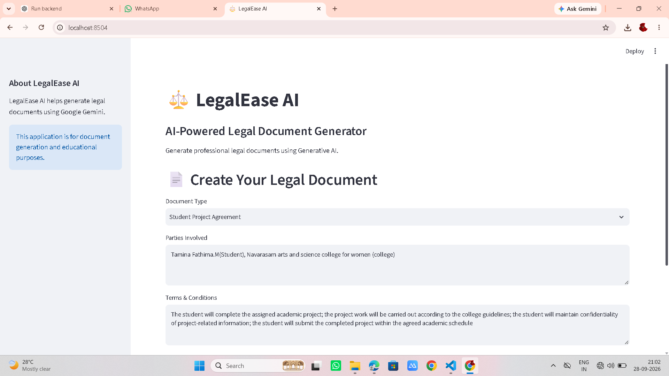
10.2 DOCUMENT GENERATION OUTPUT
After submitting the details, the generated agreement-style document is displayed to the user.
Figure 10.2: Generated Legal Document Output
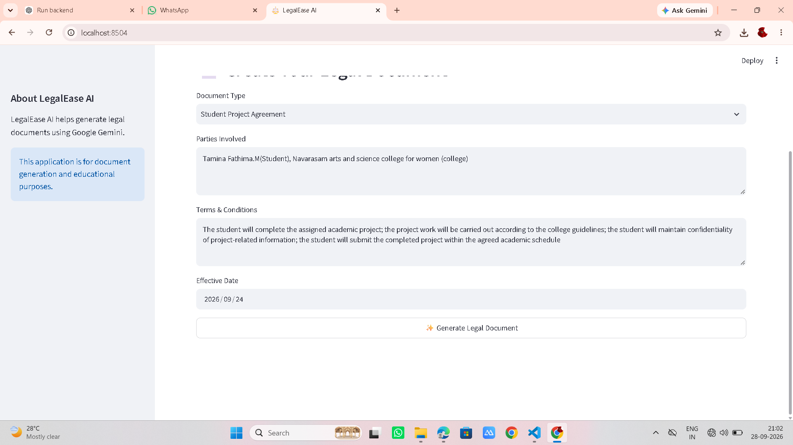

10.3 DOWNLOAD OUTPUT
The application provides three output options: TXT, Document/DOCX and PDF. These formats allow the generated draft to be stored and used for further editing or review.
Figure 10.3: TXT, DOCX and PDF Download Options
CONCLUSION
LegalEase is an AI-powered legal document generator developed to demonstrate how generative AI can be integrated into a practical software application. The system combines a Streamlit user interface, FastAPI backend, Gemini-based generation and document-formatting services.
The modular architecture makes the application easier to develop, maintain, test and extend. The project successfully demonstrates the flow from structured user input to generated agreement-style draft and downloadable output.
The application is intended for academic and demonstration purposes. Generated content should be reviewed and adapted by an appropriately qualified legal professional before being used for any real legal purpose.
FUTURE ENHANCEMENT
1. User login and personalized document history.
2. Database storage for generated documents.
3. More document templates and clause libraries.
4. Multilingual document generation.
5. Advanced formatting and digital-signature support.
6. Secure cloud deployment.
7. Additional AI model/provider support.
8. Jurisdiction-specific templates subject to professional legal review.
11. REFERENCES
1. Python Documentation – Python programming language and standard libraries.
2. FastAPI Documentation – FastAPI framework and API development.
3. Streamlit Documentation – Streamlit application framework.
4. Google Gemini API Documentation – Gemini API and Google GenAI SDK.
5. python-docx Documentation – DOCX document generation.
6. ReportLab Documentation – PDF document generation.
7. Uvicorn Documentation – ASGI server documentation.
8. Visual Studio Code Documentation – Development environment and project management.

